**Book tickets demo part 1**

1. Create a database called **bookticketdb**, add 3 tables (customer, flight, ticket) with following attributes:

customer table

flight table

ticket table

1. Add FK to customerID, flightID in the **ticket** table

Select ticket table >>Relation view

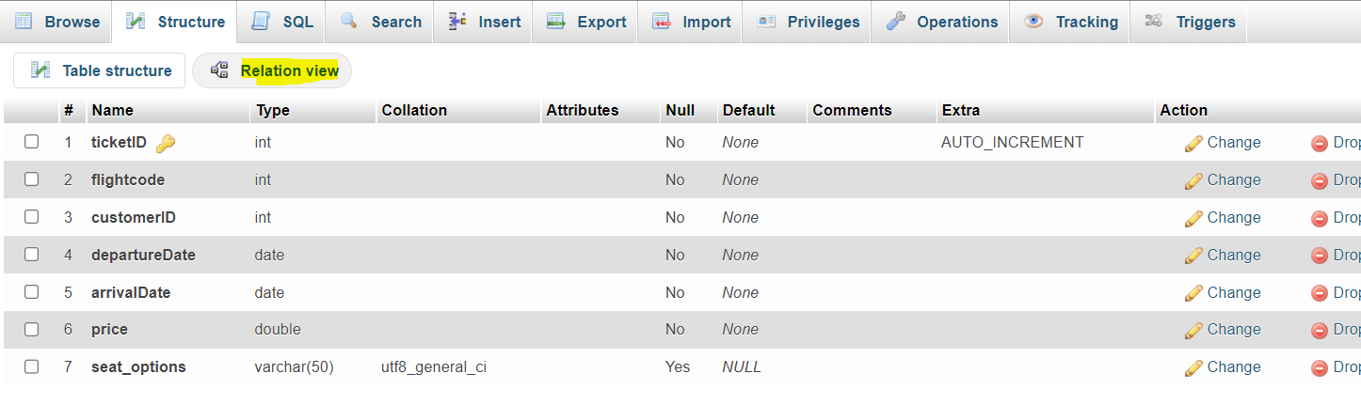

1. You can use generate to generate sample datasets from

<https://generatedata.com/>

1. Import the dataset to the database
2. Create a website folder called **booktickets** in www and open with VScode
3. Create a config.php file

<?php

//MySQL credentials

define("DBUSER","root");

define("DBPASSWORD","root");

define("DBDATABASE"," bookticketdb");

define("DBHOST","127.0.0.1");

?>

1. Create a memberslisting.php and check database connection

<body>

    <?php

        include "config.php"; //load in any variables

        $DBC = mysqli_connect(DBHOST, DBUSER, DBPASSWORD,DBDATABASE);

        // The connect_errno / mysqli_connect_errno() function returns

        // the error code from the last connection error, if any.

        //check connection

        if(mysqli_connect_errno())

        {

            echo "Error:unable to connect to MYSQL.".mysqli_connect_error();

            exit;

        }

//Display the host information

        echo "Connectted via" .mysqli_get_host_info($DBC);

        mysqli_close($DBC);

#----------

        ?>

</body>

1. registercustomer.php
2. ticketslisting.php